Change in Action| Guidance & Application Form
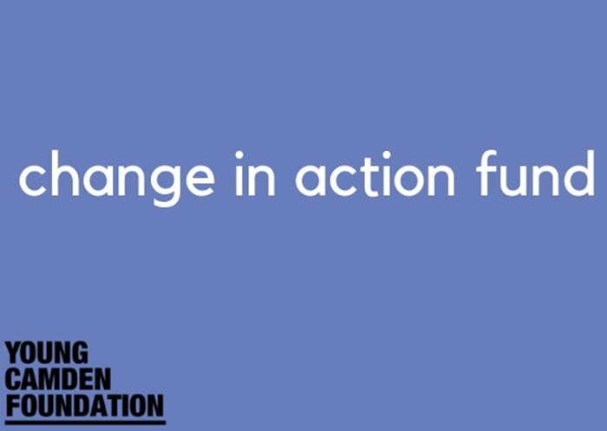

Do you have an idea for a project that is co-designed by young people; provides access to new opportunities; and promotes alternative and positive pathways?

If so, please submit your project proposal to YCF using the application form below. For information about the fund please contact grants@youngcamdenfoundation.org.uk.

What is Youth-led social action?

YCF understands youth-led social action to be creating opportunities for children and young people to design and deliver projects that will benefit others. These are some examples of social action:

- campaigning about a local issue
- tackling pollution
- fundraising for charitable causes
- organising events
- raising awareness about mental health
- combating racism and discrimination
- organising and delivering training/events
- mentoring
- or enforcing positive messages using videos or music.

Anything and everything can be used in youth led social action, as long as, young people participate in the conception, planning and delivery of the activities.

With youth-led social action activities there is a double benefit: Young people acquire or use their skills and other people benefit from the activities led by young people.

We encourage applications from projects that support young people to take action, practice self-agency and the scheme meets at least two of the following outcomes:

Required Outcome
- Improve confidence, agency and self-efficacy of young people.

Optional outcomes:
- Allows young people to make safer, more informed decisions about their futures
- Mobilises young people to take community action
- Young people build resilience and barriers to learning are removed
- Young people have access to new positive opportunities
- Existing or new partnerships are strengthened with other local community and/or statutory organisations

YCF will award grants to applications that are able to demonstrate that their projects are youth led, meet the above outcomes and have a focus on social or community action.

We invite YCF member organisations to apply for grants between £4,000 and £5,000
(Please note that this is a small pot of money and the total amount to give out is £10,800).

Are you eligible?

- Your organisation must have been a member of Young Camden Foundation for a minimum period of 3 months prior to the opening of this fund (Feb 2020)
- You must be working in the London Borough of Camden and with Camden residents aged 11– 25.
- Your organisation has not received funding from YCF in the last 6 months.
- Your organisation must have an annual turnover of £1 million or less.
- Your organisation has a bank account (registered in the name of the applicant organisation) into which a grant can be paid
- Grants cannot be for religious activities
- Grants cannot be for political activities
- Grants cannot be for trips abroad
- You must be able to provide a current Safeguarding and Data Protection Policy in support of your application
- Applications will only be considered if received by the deadline of Friday 28 February 2020.

Ready to apply?

If you have an exciting project that could be supported by our Change in Action Fund 2020, please submit your proposal via the form below.

Applications must show involvement of the beneficiaries (those that will benefit from the project, i.e. Camden young people). All applications will be reviewed by a panel made up of local young people, voluntary sector representatives, YCF’s business partner and members of YCF’s Board of Trustees
Support

Young Camden Foundation will be available to offer ongoing support where needed to ensure these projects are successful. This will include bringing services together if you have a good idea for a project to work with other groups but do not currently know any people or organisations from that community.

Important dates

Applications open: 05 February 2020

Close: Friday 28 February 2020
Panel: TBC
Award: Mid/end of March 2020

Monitoring and Evaluation commitment

YCF is interested to know how the project went and hear about the difference it made to young people and the local community, as such we will request the following information:
- Record of changes you have observed in your beneficiaries (improvement in any of the outcome areas you chose) a base line survey at the start of the project would help you record any changes.
- A report of the activities that took place (number or hours of sessions, thematic focus, any other activities).
- Attendance (number, gender and age of beneficiaries).
- Record and proof of expenditure (cash account, bills, invoices, etc.).

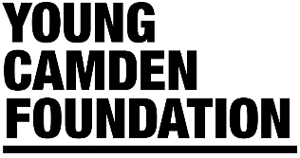
Change in Action Fund Application Form 2020
Section A: Personal and Organisation Details
Name of Organisation
Name of Lead Contact and Position
Address
Email
Phone
Mobile Phone
Alternative contact- Name and position:
Alternative contact: Phone number:
Alternative contact: Email:
Legal Status
Charity Number (if applicable)
Website
Social Media
Organisational income 2019/2020

Name of Project: _____________________________________________________________

Section B: Your Project
B1. What will your project do? (please provide details/overview of your project and the activities you will run)

B2. Why is this project needed?

B3. How will young people benefit from this project? (please describe your social action approach here)

B4. Does your project target a specific group of young people? If so, who and why?

B5. How have you involved young people in the decision making for this project? If you haven’t involved them yet please explain how you will do this?

B6. How does your project meet the outcomes of this grant? (see guidance at the top) Please list the outcomes expected.
Outcome 1: Improve confidence, agency and self-efficacy of young people. (please explain how will the project achieve this)

Please list other outcomes here and explain how they will be achieved:

B7. How many children & young people will benefit from your activity/ project? (please state expected numbers, age and gender)

B8. Project Timescales
Estimated Start Date:
Duration:
Estimated End Date:
Likely hours of project per week:
Any other information:

B9. How will you monitor and evaluate outcomes for your project?
If you require monitoring and evaluation support, please get in touch with the YCF team at grants@youngcamdenfoundation.org.uk

Section C: Budget
Total applied for: £
Total value of the project: £
Total match funds: £
What will your project cost and how will you spend the money? Please provide a detailed budget (attach if necessary). Tell us of any match funding you will be using to deliver the project.
Description | Amount requested from YCF £ | Other income/match funds
Total | £ | £

Will you get additional funding to support the project? (if yes please say where from)

How will you keep a record of spending?

Once completed, please return form to: grants@youngcamdenfoundation.org.uk
If you have any difficulties completing or submitting this form, please email the address above.
Applications close on 28 February 2020. Decisions will be announced mid/end of March 2020.

