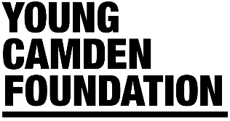

Heads Up | Eligibility Criteria

Are you eligible?
- Your organisation must be a member of Young Camden Foundation. Joining is free by filling our online form: https://www.youngcamdenfoundation.org.uk/members
- You must be based and working in the London Borough of Camden with Camden residents aged 0 – 25 (and up to aged 30 with additional needs).
- Charities, schools and other not for profit organisations based in Camden can apply.
- Your organisation has a bank account (registered in the name of the applicant organisation) into which a grant can be paid.
- Your organisation has a constitution.
- Grants cannot be for religious activities.
- Grants cannot be for political activities.
- Grants cannot be for trips.
- You must be able to provide a current Safeguarding and Data Protection/GDPR Policy in support of your application.
- All funded projects will need to fill in a simple monitoring and evaluation form containing a description of what has been achieved, the number of children and young people or staff benefiting from the mental health project and receipts of items purchased.
- The projects will need to be up and running after a month of receiving the grant. If your project cannot meet these timing please explain this in your application.
- Applications will be considered on a rolling weekly basis opening for applications on 22 June 2020 with the following deadlines: 03 July, 10 July, 17 July, 24 July, 31 July. August deadlines will be announced at the end of July. The assessment panel will meet approximately every other week during July, August & September or until all funds are allocated.

