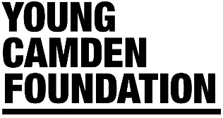

Digital Youth Work Fund | Eligibility Criteria

- Your organisation must be a member of Young Camden Foundation. Applications are only invited from organisations which have completed the membership process. Joining is free by filling our online form. Join here: https://www.youngcamdenfoundation.org.uk/members
- You must be working in the London Borough of Camden and with Camden residents aged 0 – 25 (and up to aged 30 with additional needs).
- Your organisation has a bank account (registered in the name of the applicant organisation) into which a grant can be paid.
- Grants cannot be for religious activities.
- Grants cannot be for political activities.
- Grants cannot be for trips.
- You must be able to provide a current Safeguarding and Data Protection/GDPR Policy in support of your application.
- The fund will be available in three waves. Applications will be considered on a rolling basis with the following deadlines: 29 May, 19 June & 03 of July 2020.
- All projects will need to fill in a simple monitoring and evaluation form containing a description of what has been achieved, the number of children and young people benefiting from the new/enhanced digital offer and receipts of items purchased.
- The projects will need to be up and running after a month of receiving the grant. If your project cannot meet these timing please explain this in your application.

