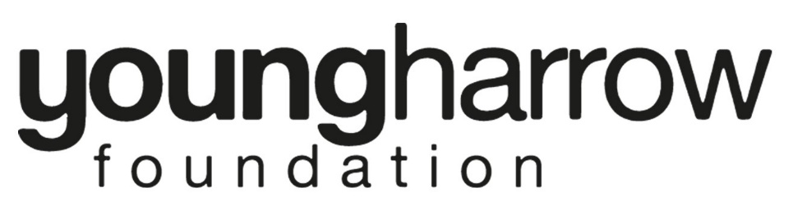

Job description - Chair of TrustEEs

Remuneration | The non-executive, voluntary role of Chair is not accompanied by any financial remuneration, although expenses for travel and other costs on YHF business, including unavoidable and allowable childcare may be claimed.
Location | Harrow, London
Commitment | 4/5 Board meetings a year (varying times usually on Thursdays) and an Awayday and Annual General Meeting. Active involvement in task and finish working groups as required. Overall a minimum of 2 days per month.
Reporting to | Board of Trustees

What will you do?
The key role and responsibilities of the Chair are to:
- Chair Board meetings effectively and efficiently and in a way which respects diversity, transparency and accountability
- Work with the CEO in planning the Board meetings agenda and ensuring high quality papers for Board meetings
- Ensure effective and efficient strategy and governance processes, including appropriate policies and risk management processes are in place
- Support, develop and motivate trustees and any Board advisers
- Ensure proper induction, training and development for trustees
- Prepare with the CEO arrangements for the Annual General Meeting and chair the meeting
- Ensure proper arrangements for Board and individual trustee appraisal
- Ensure effective supervision and appraisal of the CEO
- Ensure proper duty of care to all YHF staff
- Represent YHF as required from time to time.

we need you to have the following skills and expertise
Personal skills and expertise required
- Leadership and motivational skills
- Good understanding and knowledge of the charity sector
- Good communication and interpersonal skills; able to engage and listen at all levels
- Able to build productive relationship with CEO and key staff and volunteers
- Able to reach clear decisions by consensus
- Good planning and organisational skills
- Ability to build a cohesive team and work well as part of the team
- Personal integrity, independence of mind and willingness to challenge and question
- An active commitment to equality, diversity and inclusion.

CHAIR as a trustee
The Chair is also a trustee with all the responsibilities of a trustee. Trustees have important roles to play in overseeing the governance and strategy of YHF. The current YHF trustees offer a diverse range of backgrounds, experiences and skills which add considerable value to our decision making.
The role of a Trustee is to ensure that Harrow Young Foundation fulfils its responsibilities to its members and other stakeholders and meets its strategic and operational outcomes in full accordance with our key values - Inclusion, Integrity and Innovation.
The statutory duties of a trustee are to:
- Ensure the organisation complies with its governing document - sometimes known as a trust deed, constitution, or articles of association.
- Ensure that the organisation pursues its objectives as defined in its governing document.
- Ensure the organisation applies its resources exclusively in pursuance of its objectives - the charity must not spend money on activities which are not included in its own objectives, no matter how 'charitable' and 'worthwhile' those activities are.
- Contribute actively to the Board of Trustees' role in giving firm strategic direction to the organisation, setting overall policy, defining goals and setting targets and evaluating performance against agreed targets.
- Safeguard the good name and values of the organisation.
- Ensure the effective and efficient administration of the organisation.
- Ensure the financial stability of the organisation.
- Protect and manage the property of the organisation and to ensure the proper investment of the organisation's funds.
- If the organisation employs staff, to appoint the Chief Executive Officer and monitor his or her performance.
In addition, with other trustees to hold the charity “in trust” for current and future beneficiaries by:
- Ensuring that the charity has a clear vision, mission and strategic direction and is focused on achieving these.
- Being responsible for the performance of the charity and for its “corporate” behaviour; ensuring that the charity complies with all legal and regulatory requirements.
- Acting as guardians of the charity’s assets, both tangible and intangible, taking all due care over their security, deployment and proper application.
- Ensuring that the charity’s governance is of the highest possible standard.

As well as the various statutory duties, any trustee should make full use of any specific skills, knowledge or experience to help the board make good decisions.
The above list of duties is indicative only and not exhaustive. The Trustee will be expected to perform all such additional duties as are reasonably commensurate with the role.

Aim - Mission - Values
Better, sustainable, high quality support services for children and young people in Harrow
Happier, healthier, safer children and young people with more opportunities to reach their full potential
Innovative Integrity Inclusive

YHF ThEory of CHANge
