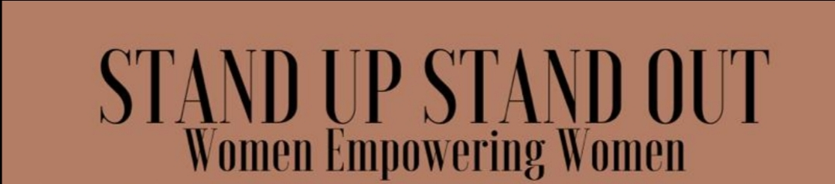
We are holding a 6-week workshop to help young women discover themselves by focussing on: self-care, self-esteem, wellness, team building activities, managing their social media, vision boards, guest speakers & MORE
Project run time: Tuesday 3rd November 2020- Thursday 10th December 2020
4:30-7:30pm, Young women aged: 16-24years

Week 1  Tuesday 3.11. | Week 2  Tuesday 10.11 | Week 3  Tuesday 17.11 | Week 4  Tuesday 24.11 | Week 5  Tuesday 1.12 | Week 6  Tuesday 8.12
Introductions &  Team-building  25mins  Break – 10mins  Mood boards  Culture check  25mins  Break - 10mins  Yoga & Meditation (1hr) | Hair & Beauty (1hr)  Break - 10mins  Mood boards (20 min)  Break – 10mins  Yoga - 30mins | Empowerment/ workshop- With Renee (30 mins)  Break – 10mins  Mood boards (20mins)  Break (10min)  Yoga &  Meditation  (50mins) | Hair & Beauty (1hr)  Break - 10mins  Mood boards (20 min)  Break – 10mins  Yoga - 30mins | Empowerment/ Workshop- Meera 20mins  Break- 10 mins  Workshop (30mins)  Break -10mins  Yoga & Meditation  (50 mins) | Guest – Aromatherapy  (30mins)  Break -10mins  Workshop – 20mins  Break – 10mins  Yoga & Meditation
Thursday  5.11 | Thursday  12.11 | Thursday  19.11 | Thursday  26.11 | Thursday  3.11 | Thursday  10.11
Guest speaker  (30 mins)  Break- 10mins  Q&As – 20mins  Mood /nutrition (20mins)  Break –10mins  Meditation freq. | Workshop with Renee (1hr inc 10 min break)  Break –10 mins  Zumba - 40mins | Sexual health workshop (1hr inc. 10 min break)  Nutrition 20mins  Break –10 mins  Yoga - 20mins | Workshop with Renee (1hr inc 10 min break)  Break – 10mins  Dance aerobics-  30mins | Guest speaker & workshop  1hr inc 10min break  Nutrition 20mins  Break –10 mins  Yoga - 20mins | Celebration  Special guest appearance

